My year as a Parkrun tourist
By Amanda Rankin

At the beginning of 2014 my planned running goal was to try and achieve PBs in all the standard distances. However emergency surgery and a forced 6 week break from running led to a bit of a rethink. It was my husband who came up with the new idea - 12 different parkruns over 12 months. I think his logic was he would get a weekend away on the pretext I got to try out some new races!
I had already completed Parkrun number 1 – Coventry - just 4 days before my surgery. Coventry parkrun takes place in War Memorial park, a 20 minute walk from our hotel. It was a 2 and a bit lap course with a very muddy start but then it moved onto the wide tarmac paths. The park itself was very interesting with several plaques dedicated to those who lost their lives in the 2 world wars and the magnificent memorial at its centrepiece. I would like to revisit and spend more time exploring the facilities and history of the park. On this occasion having completed the run in 32.31 (not bad considering I was, unbeknown to me, harbouring a rather nasty appendicitis and was dosing up on painkillers) we headed back to the hotel for a well earned breakfast. One of the most interesting parks I have visited and Coventry itself was well worth visiting with the free Motor museum, the old and new cathedrals and plenty of shopping too!
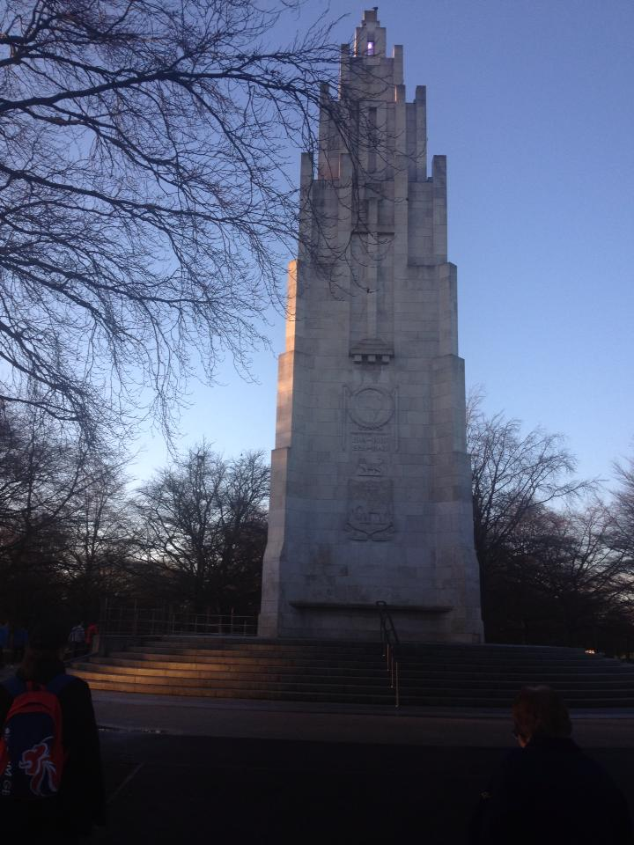
The Memorial in the Park

Parkrun number 2 at the end of March was the more local St Albans .I chose this as my first race post surgery as I knew there was no pressure and the 3 lap flat course was familiar. I took it easy and managed to complete it in 33.47.
A visit to Wales in April for an overdue catch up with my cousins also gave me a chance to add Parkrun number 3 to the list. There were three to choose in the area but I opted for Pontypool Park. It turned out to be a good choice. A deceivingly large park the route was 2 laps on tarmac paths including a very pretty blossom tree lined hill where you were rewarded with lovely views of the mountains at the top. Unusually you did a lap around the rugby stadium based in the park to the finish. A very well organised Parkrun with km markers and a volunteer photographer. I enjoyed this one and we revisited the park later in the weekend as I was born in Wales and it was good to see some of the places my dad had grown up with and I’d heard so much about. 31.02 was a reasonable time considering the hill and I would definitely do this one again.

May was Parkrun number 4 –Ashford in Kent. This time I was accompanied by my good friend and ex-strider Barbara who I was staying with. Ashford was about 25 minute drive from Folkestone where she lives. It was a bit of a dismal morning and this may be what spurred me on to get a time of 29.29 which I was very pleased with. Taking place in Victoria Park, Ashford it was a 2 lap mainly flat course. The park was a fairly ordinary town park with a very unusual fountain as its main feature. Not one of my favourites but it ticked another one off the list.
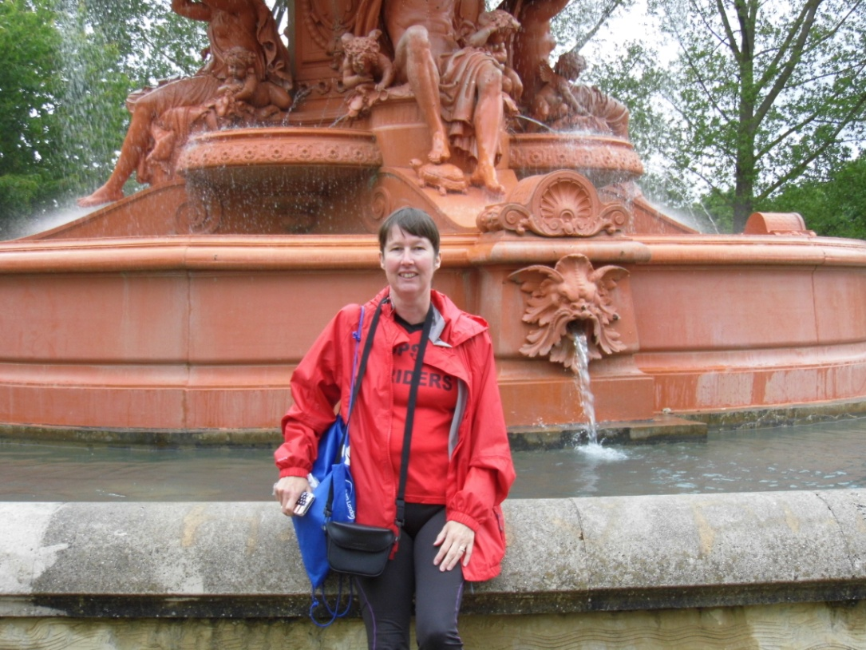
The fountain in Victoria Park, Ashford.
In June I returned to a more local one - Bedford - but it wasn’t quite an ordinary run as it was their third anniversary so fancy dress, cake and fun were the order of the day. I managed to beat the man running in a wetsuit but not the man in a full three piece suit! 31.06 for this one wasn’t bad.
I did beat this time later in the year at the Doug Anderson 5k which follows almost the same route. We also took the opportunity for a cup of tea at the new kiosk in the park itself.
In July we took the opportunity to add an extra day to our summer holiday and had an overnight stop at Taunton where I took part in the aptly named Longrun Meadow Parkrun - number 6 on the list. This was a very different park to the others I had done; it was very flat and was more meadow as name suggests than park. 2 laps done in a time of 30.53. Some parts of the course were quite narrow so no real PB potential unless you’re right at the front. I didn’t find it a particularly enjoyable course but the marshals were very supportive. We just managed to dodge a heavy shower before setting off to Cornwall where Parkrun number 7 was planned for the end of the week.
We had a fabulous week in Cornwall, met with old friends, squeezed in 2 more 4 mile races and spent a lot of time in the sea. With hindsight this maybe why I found Lanhydrock Parkrun in Bodmin such a struggle. It was an early start to get there and the weather was typical English summer - grey and drizzly! It was billed as an all off-road trail Parkrun and certainly lived up to its name. The one lap circular route took in fields, woods and hills. It was definitely a tough one and I ended up walking up the last hill before gratefully reaching the downhill finish section. 35.59 was my worst time for a 5k in a long while and I was pleased to finish.Lanhydrock is a National Trust property complete with stately home and seemed very popular with coach trips. Unfortunately I didn’t really appreciate this as my legs were protesting too much.
Number 8 was another off road Parkrun and one which was a lot tougher than expected. Again we combined a family visit with the Parkrun challenge and booked a weekend in Croydon to spend time with my brother and his family. The nearest Parkrun was Lloyd Park where I met up with my sister in law ready to run. It’s a big park with a tram line running along the outskirts. Naively being London I was expecting flat tarmaced paths. What I got was grassy trails, hills and a fair smattering of mud. 33.34 minutes later I finished with great admiration for sister in law who had tackled this course as her very first 5 k only a few weeks earlier.
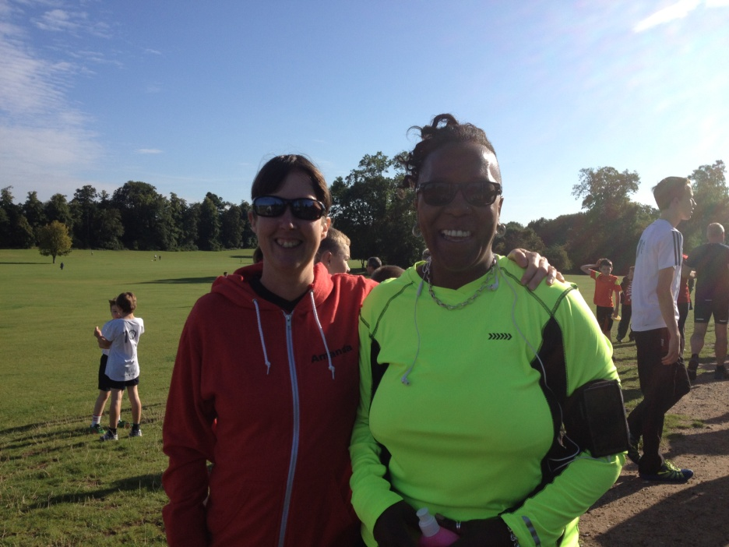

In August I took my boys up to the Lake District so couldn’t miss an opportunity to add Parkrun number 9 to the tally. There was Barrow nearby which I had done last year so instead I decided on Workington on the north west of the Lakes. This was a much easier run then some of the recent ones. An out and back along a bike path. There was a slight incline which made the return part of the run much easier. Not a particularly scenic run considering it was in the Lake District but very friendly and I spent half an hour after chatting to some of the volunteers over a cup of tea. My time finally dipped below the 30 minutes again at 29.17. My son managed 5 minutes faster!
September took me back to Folkestone to visit Barbara again but now Folkestone had its very own Parkrun. I really enjoyed this one. It ran along the Leas with fabulous views over the sea and through the coastal park. It does have some challenging hills but it’s an interesting course and definitely one I would like to do again. I just missed the sub 30 at 30.03 but I blame Barbara for distracting me at the marshal point!
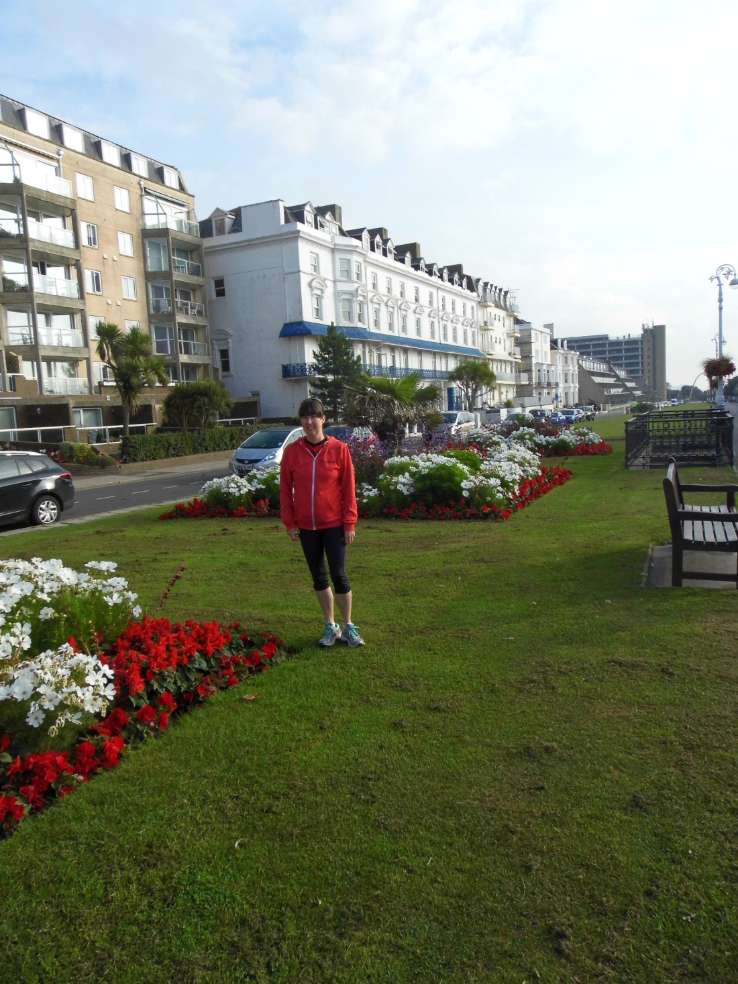

Number 11 was too good an opportunity to miss - the very first Tring parkrun. On a lovely sunny morning I joined over 200 runners in this new event. It takes place in Tring Park, just past the National History museum. Organisation was fabulous and the atmosphere was great. Again it was a tough course starting on a long uphill before turning into the woods. A few more hills had to be tackled before the end and we even got a bit of support from the local cows wandering around the field. A good parkrun if you enjoy cross country.
My final for the year - Number 12 - was another off road course- Panshanger. It was a cold, clear winter’s day and there was a heavy frost covering the course. This probably actually helped as the frozen ground looked very churned up and could have been very muddy. I did this with fellow Strider Nikki Cox who was doing her first ever Parkrun. We got round in a respectable 33.06 and managed to stay upright despite the ice. Well marshalled and a nice course.
And so my goal was achieved. It’s been fun, well most of the time, and through running I have visited parks that otherwise I would never have known existed. I will continue to try different parkruns next year and hopefully if all goes well these will include not only Hitchin but our very own Luton Parkrun!

